Developer manual Asciicam
Asciicam is an application developed mainly for android phones running version 2.2 or above. In order to start developing from this project, please do the following:
- Clone workspace from https://github.com/Ossianm/Grupp29Asciicam .
- Install development software Eclipse, Android SDK, Android AVD (For testing), Java SE6 and all android addons for eclipse.
- Create a new testproject for Grupp29Asciicam named AsciicamTest and copy all inside test folder to the project.

Application flow
Below is a flowchart diagram which describes how the application is intended to work for a user:
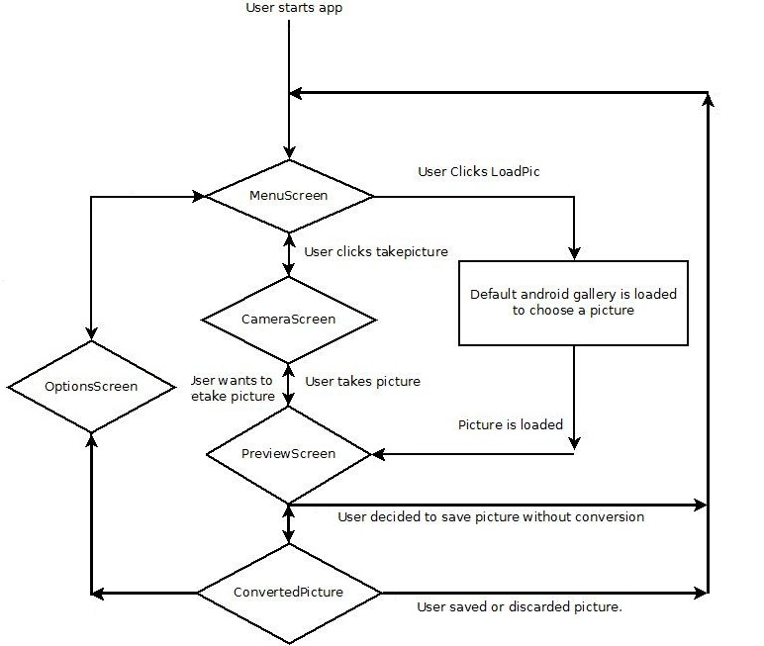
All diamond cells are intended to be Activities using android API or custom made APIs to perform tasks.

Class Model
Packages in the project:
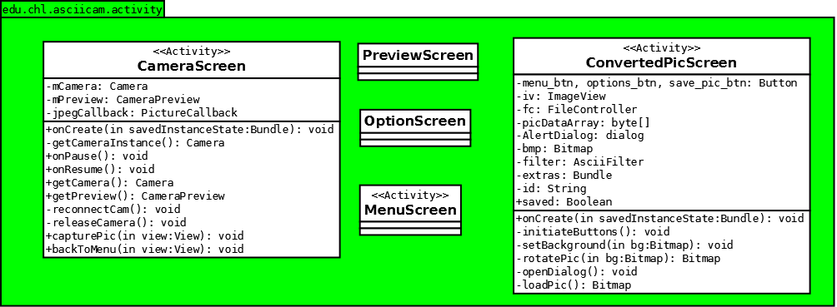
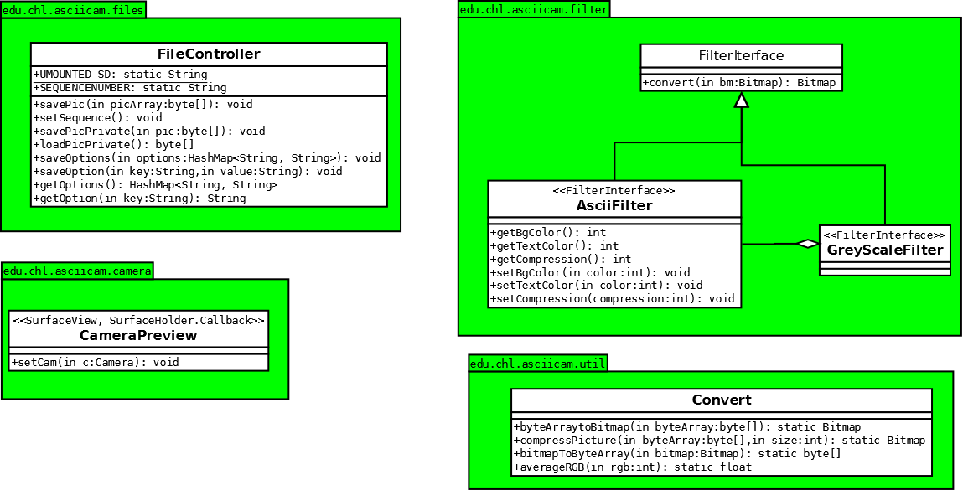
As we can see in the chart, the intention is to create 3 APIs, one for camera, one for filehandling and one for the filter. The rest of the coding should be handled by public APIs in the activities.

Testing
It is really important to create a new android test project for testing.
In Eclipse choose New --> Other --> Android --> Android Test Project and name it AsciicamTest.
The source code for testing is included in github reopsitory but it will not compile and run without being imported to a test project. It is also important to note that a AVD (Android Virtual Device) or a phone connected by USB is required to run the test project.

